Assessment Team Report

The Assessment Team comprised of following three members visited the Department of Human Nutrition on September 27, 2012 in order to assess its B.Sc (Hons) degree program:

- Prof. Dr. Saleem Khan Convener AT
- Mr. Niamatullah Khan AT Member
- Ms. Mahpara Safdar AT Member
- Dr. Muhammad Ayub External AT Member

The above team in its meeting with the Program team, QEC officials, Dean and Chairman, identified the following Strength and Weaknesses of the program:

Strengths:

- The current teaching staff is well- qualified. Some of the teaching staff is pursuing their higher studies i.e.Ph.D.

- The department has one laboratory facility for undergraduate students.

- The classes are being taught regularly and course contents are completed within the stipulated period.

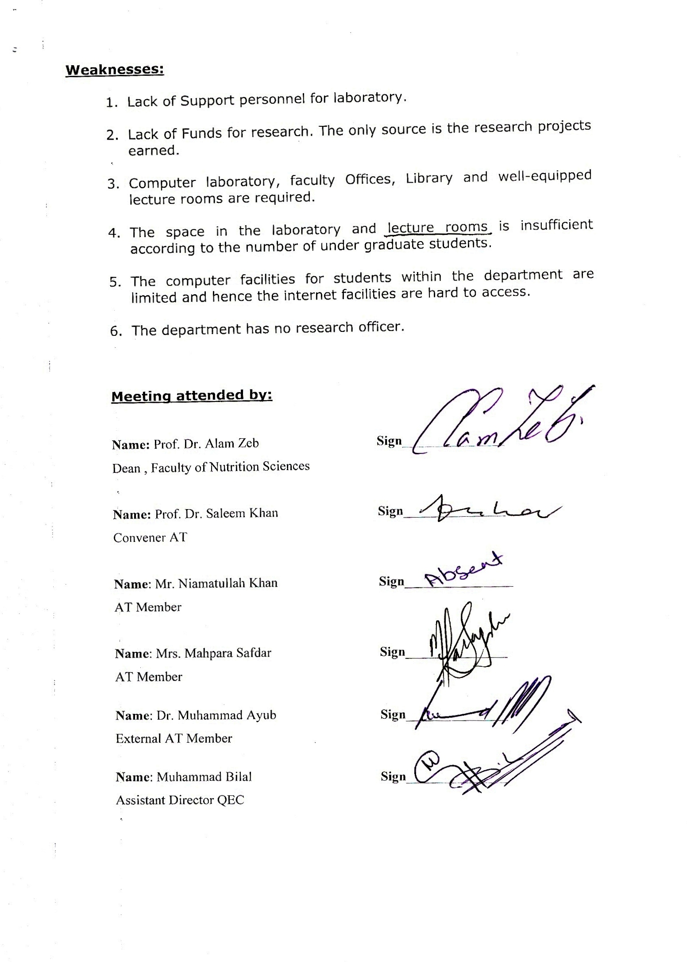

Weaknesses:

- Lack of Support personnel for laboratory.

- Lack of Funds for research. The only source is the research projects earned.

- Computer laboratory, faculty Offices, Library and well-equipped lecture rooms are required.

- The space in the laboratory and lecture rooms is insufficient according to the number of under graduate students.

- The computer facilities for students within the department are limited and hence the internet facilities are hard to access.

- The department has no research officer.

Meeting attended by:

Name: Prof. Dr. Alam Zeb Sign_______________
Dean , Faculty of Nutrition Sciences

Name: Prof. Dr. Saleem Khan Sign_______________
Convener AT

Name: Mr. Niamatullah Khan Sign________________
AT Member

Name: Mrs. Mahpara Safdar Sign_______________
AT Member

Name: Dr. Muhammad Ayub Sign_______________
External AT Member

Name: Muhammad Bilal Sign_______________
Assistant Director QEC

